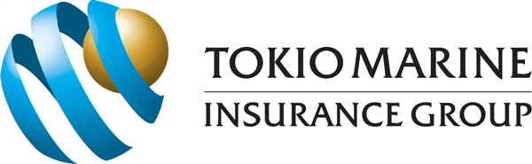
PAYMENT ADVISORY
Please find the following payment options for your settlement.

BANK TRANSFER
DBS Current Account | : 003-904549-2
OCBC Bank | : 501-148894-003
DIGITAL PAYMENT
PayNow UEN No | : 192300014MSD2  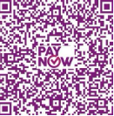  PAYNOW QR CODE -SCAN TO PAY
CHEQUE ISSUANCE
Cheque Payable | Tokio Marine Insurance Singapore Ltd  Cheque Mailing Address :  Tokio Marine Insurance Singapore Ltd.  20 McCallum Street #09-01 Tokio Marine Centre Singapore 069046
PAYABLE AMOUNT
 | $

IMPORTANT NOTE:
- For Direct Cheque Deposit, please email the Cheque Image with Policy Number / Insured Name to uwa@universalwealth.com.sg for payment acknowledgement.
- For PayNow, please indicate the Policy Number / Insured Name (max 25 character) under REFERENCE No. and email the completed transaction to uwa@universalwealth.com.sg for payment acknowledgement.
- Cheque Mailing Address : Tokio Marine Insurance Singapore Ltd. , 20 McCallum Street 09-01 Tokio Marine Centre Singapore 069046

