PAYMENT ADVISORY FOR CHUBB INSURANCE
To provide you with more flexibility and convenience, we are pleased to inform you that we are opening additional payment channels for premium payment. Appended below is the list of payment channels available for your easy reference:

BANK TRANSFER
Bank’s Name  Bank Code  Branch Code  Beneficiary’s Name  Account No | : DBS Bank Ltd  : 7171  : 003  : Chubb Insurance Singapore Limited  : 003-952178-2
DIGITAL PAYMENT
PayNow UEN No | : 199702449H  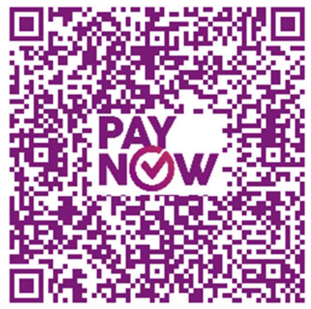  PAYNOW QR CODE -SCAN TO PAY
AMOUNT PAYABLE
 | $

